DPSS Galvo Calibration Procedure

# What problems this procedure solves

1. Stretching in 1 or both axes
2. Local distortions in the laser tool path

# Potential causes of these problems

1. Axis Stretching
   1. This could be caused by changes in the optics over time (or after recalibration of the optics)
   2. This could also be caused by local deformations in the lens/optics
   3. This could also be asymmetric (stretched more on one side of 0 than the other)
2. Local Distortions
   1. This is caused by local deformations in the f-theta lens

# How is this fixed in our setup?

We fix galvo calibration issues in the ProLase software 2 ways:

1. A correction table to fix local deformations
2. Scale factors to fix the macroscopic stretching

# Generate Correction Tables

## Cut Calibration Points

1. Prepare a slide with really anything to cut.
2. Copy the previous correction field folder and date it accordingly
3. Open **Calibration.LAZ** in Prolase. It should look like this:
   1. INSERT PICTURE OF CALIBRATION.LAZ
4. Ensure your origin is set correctly
   1. Focus on some material
   2. Zero the origin on the stage box
   3. Cut the “SingleCross” object in the **Calibration.LAZ** file
   4. Move back to the camera view
   5. Measure the deviation via the encoder counts in GalilTools
   6. Update the origin shift properties in the stage program in GalilTools
5. Prepare a new slide
6. Cut the “Grid” object in the **Calibration.LAZ** file

## Determine the New Correction

1. Using the excel sheet, update the green columns with the X and Y coordinates of the drill points using encoder counts.
   1. INSERT PICTURE OF CALIBRATION POINTS HERE
2. Copy the coordinates into a text file and save it with an intelligent name.
3. Run **GalvoCal.m**
   1. When prompted, select the new calibration data (.txt), the old calibration table (.ctb), and the name of the new calibration table (.ctb) you want to generate.
   2. The script automatically generates your new correction table file (.ctb)
   3. The script also prints the X and Y scale factors to the command line. Write these down!

## Update ProLase

Now that you have a new Correction Table and new scale factors, you need to navigate the maze of interfaces in ProLase to set them in software.

1. Copy the new correction table (.ctb) to 2 locations:
   1. INSERT FILE LOCATIONS FOR PROLASE CALIBRATIONS
   2. INSERT FILE LOCATIONS FOR PROLASE CALIBRATIONS
2. Open the “Drivers Settings” menu  
   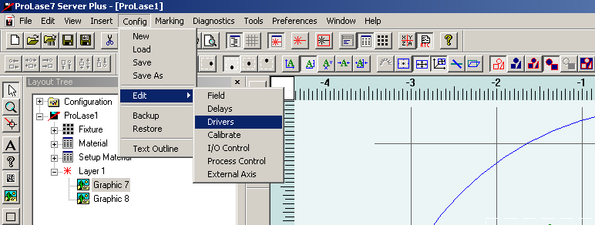
3. Click SCANLAB RTC4 (even though it’s already clicked)

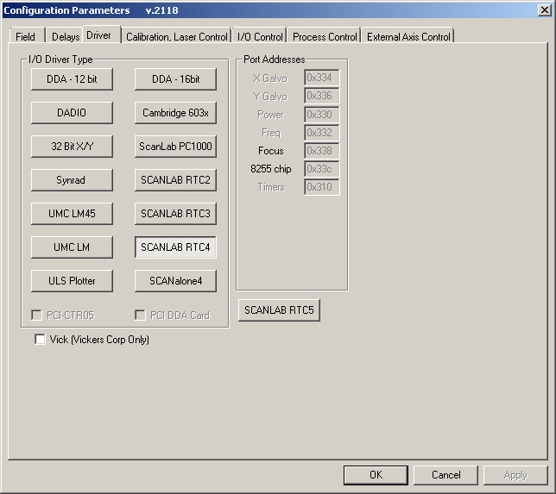

1. Set “Correction File 1” and “Correction File 2” to your new .CTB file.

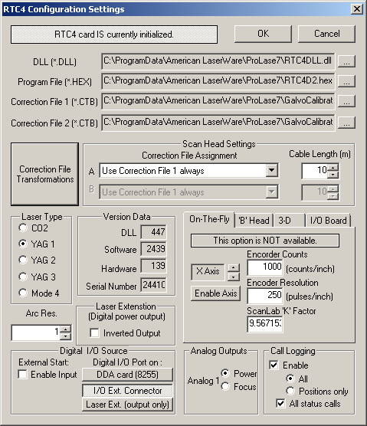

1. Open the “Correction File Transformations” dialog
2. For each of the axes, multiply the current “Gain” from ProLase by the scale factors you wrote down from Matlab.  
   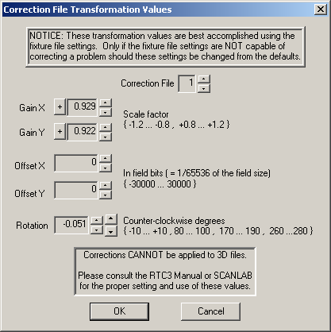
3. Do another cut of the grid and measure it to ensure the calibration was completed successfully.
4. Congrats, you just re-calibrated the galvos!